**CSE 3241 Project Checkpoint 02 – Relational Model and Relational Algebra**

Names: Group 08 Han Han, Tongshuai Zhang, Lance Chen, Yuliang Fu Date: 10/05/2018

In a **NEATLY TYPED** document, provide the following:

1. Provide a current version of your ER Model as per Project Checkpoint 01. If you were instructed to change the model for Project Checkpoint 01, make sure you use the revised version of your ER Model.

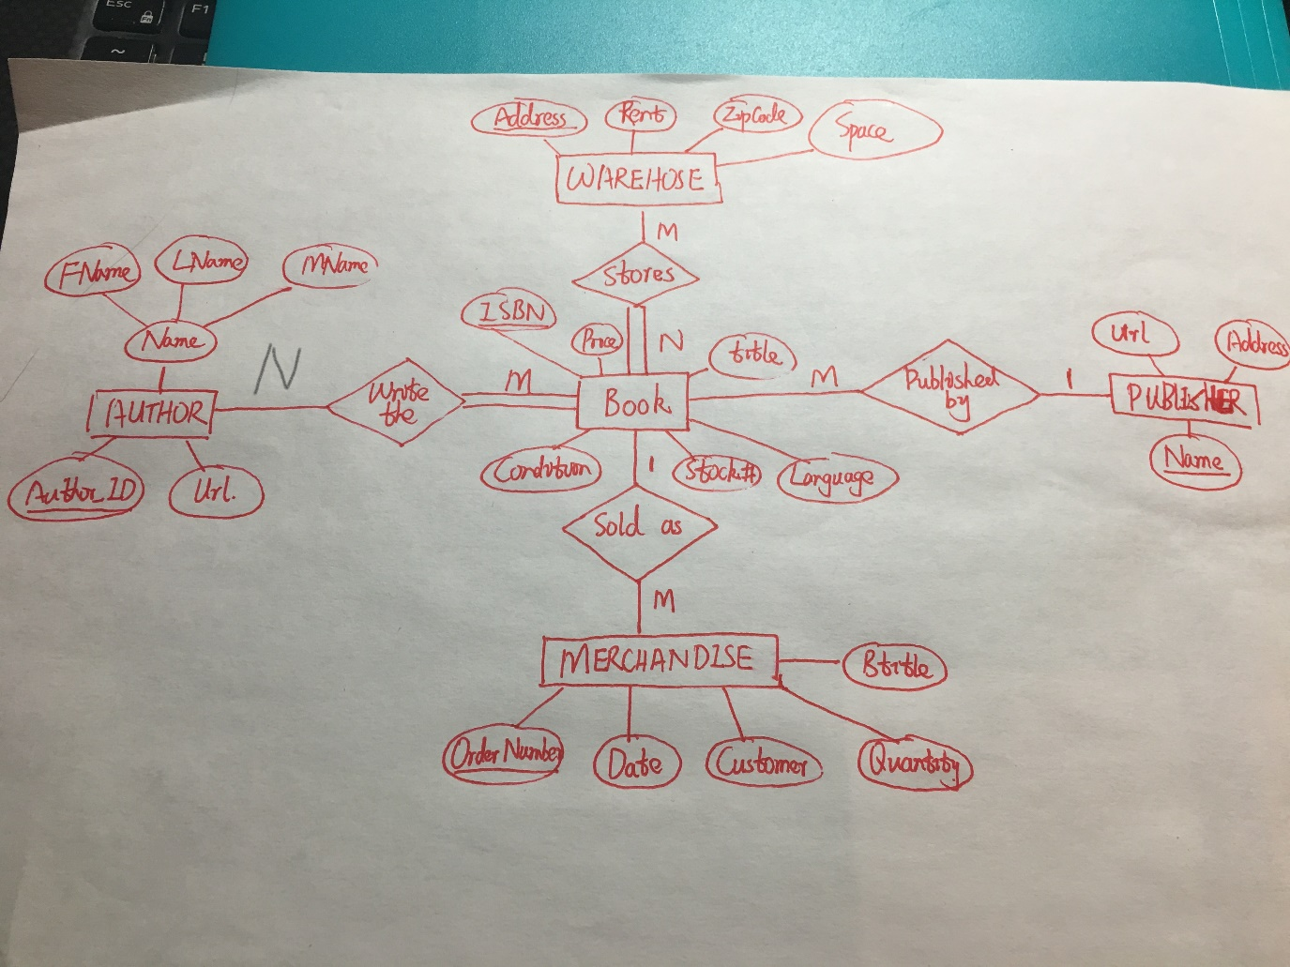

1. Map your ER model to a relational schema. Indicate all primary and foreign keys.

**Note: Red color means FORIGEN KEY, UNDERLINE means primary key.**

* **AUTHOR**: Fname, Lname, Mname, ID
* **WAREHOUSE:** Address, Rent, ZipCode, Space
* **BOOK**: ISBN, Price, Title, Condition, Stock#, Language, **AuthID, PubName**
* **PUBLISHER**: Name, Url, Address
* **MERCHANDISE:** OrderNum, Quantity, Customer, BTitle, **ISBN_Num**
* **AUTHRO_BOOK: ISBN_Num, AuthID**
* **WAREHOUSE_BOOK:ISBN_Num,WareAddress**

1. Given your relational schema, provide the relational algebra to perform the following queries. If your schema cannot provide answers to these queries, revise your ER Model and your relational schema to contain the appropriate information for these queries:
   1. Find the titles of all books by Pratchett that cost less than $10

**R1A: σ( Fname =”Pratchett” )(BOOK * AUTHOR)**

**R1B: σ( price < 10 )R1A**

**Result: π(Title )R1B**

* 1. Give all the titles and their dates of purchase made by a single customer (you choose how to designate the customer)

**π(BTitle, Date )σ( Customer =”XXX” )MERCHANDISE)**

* 1. Find the titles and ISBNs for all books with less than 5 copies in stock

**π(Title, ISBN) σ( Stock < 5 )BOOK )**

* 1. Give all the customers who purchased a book by Pratchett and the titles of Pratchett books they purchased

**R4A: (BOOK * AUTHOR * MERCHANDISE )**

**R4B: π（Customer）(σ( Name = ”Pratchett” AND Title = ”Pratchett” )R4A)**

* 1. Find the total number of books purchased by a single customer (you choose how to designate the customer)

**Sum(Quantity) (σ( Customer=”XXX” )MERCHANDISE )**

* 1. Find the customer who has purchased the most books and the total number of books they have purchased

**Max( Customer Sum(Quantity) (π（Customer, quantity）MERCHANDISE) )**

1. Come up with three additional interesting queries that your database can provide. Give what the queries are supposed to retrieve in plain English and then as relational algebra. Your queries should include joins and at least one should include an aggregate function. At least one of your queries should use “extra” entities you added to your model in Checkpoint 01

* **RETRIEVE the Price, Title, and WareAddress for the book whose ISBN is ~~~**
* **GET all tuples in AUTHRO_BOOK and WAREHOUSE_BOOK.**
* **FIND the tuples of the books created by the author ‘~~~’’.**